**Cloud Computing Practical 2**

**CREATE AMAZON S3 BUCKET**

**Neha T Mathew (A069)**

**1)Upload a basic html page**

Save a basic html code in a notepad as “Page.html”

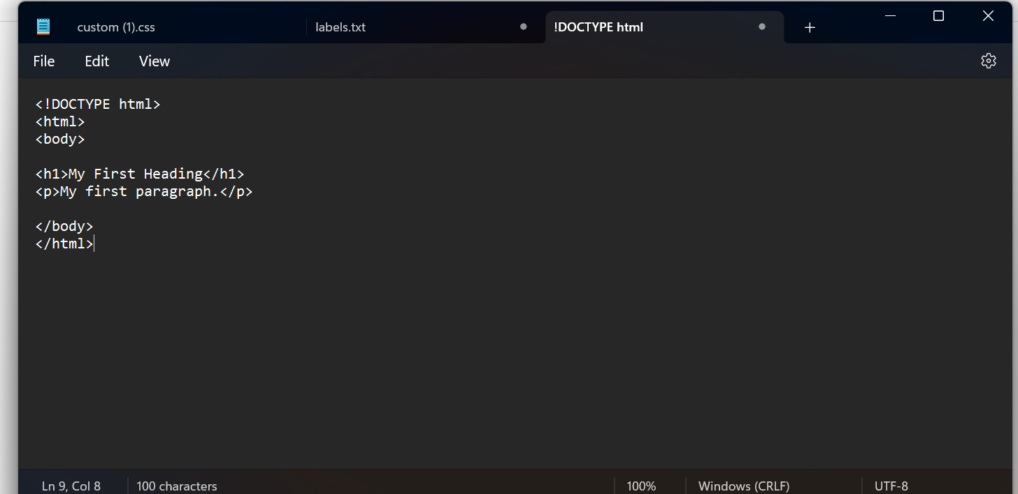

2)Navigate to aws website and search S3 . Next click on create bucket.

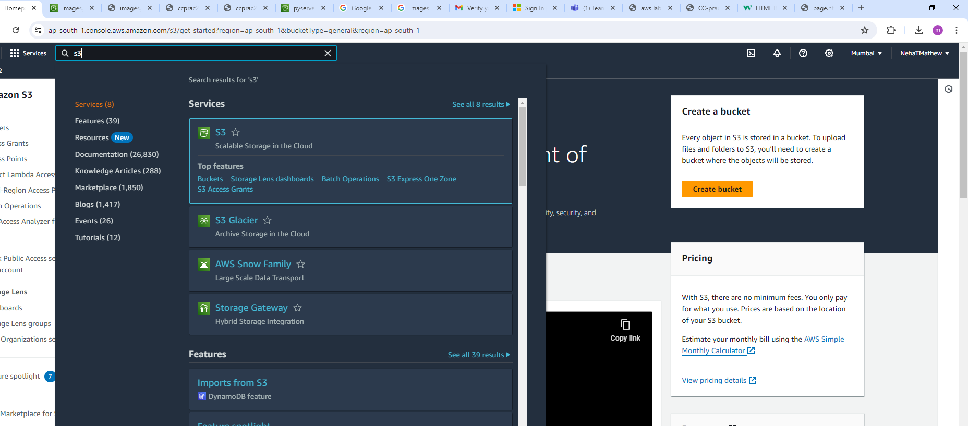

3)Create a new bucket name such as “ccprac21”.

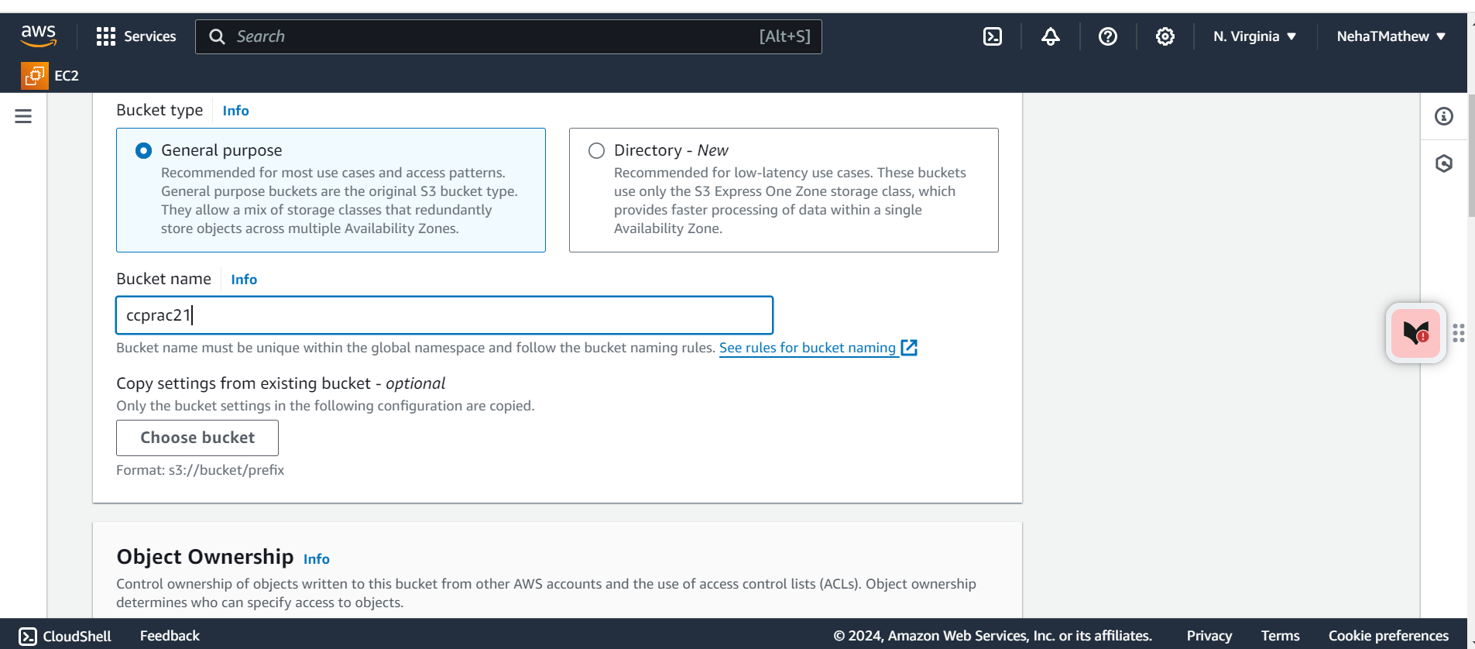

4)Click on Create a folder and provide a folder name

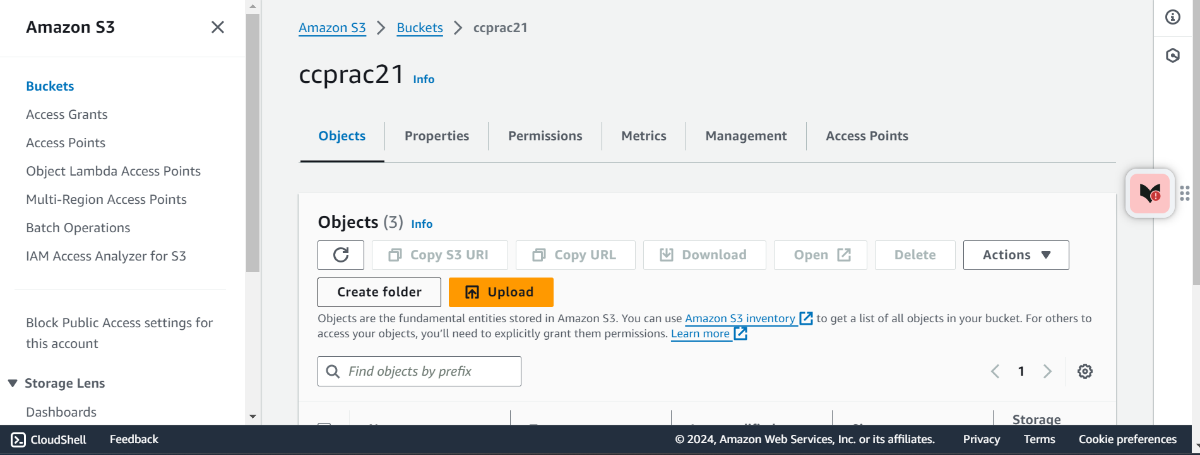

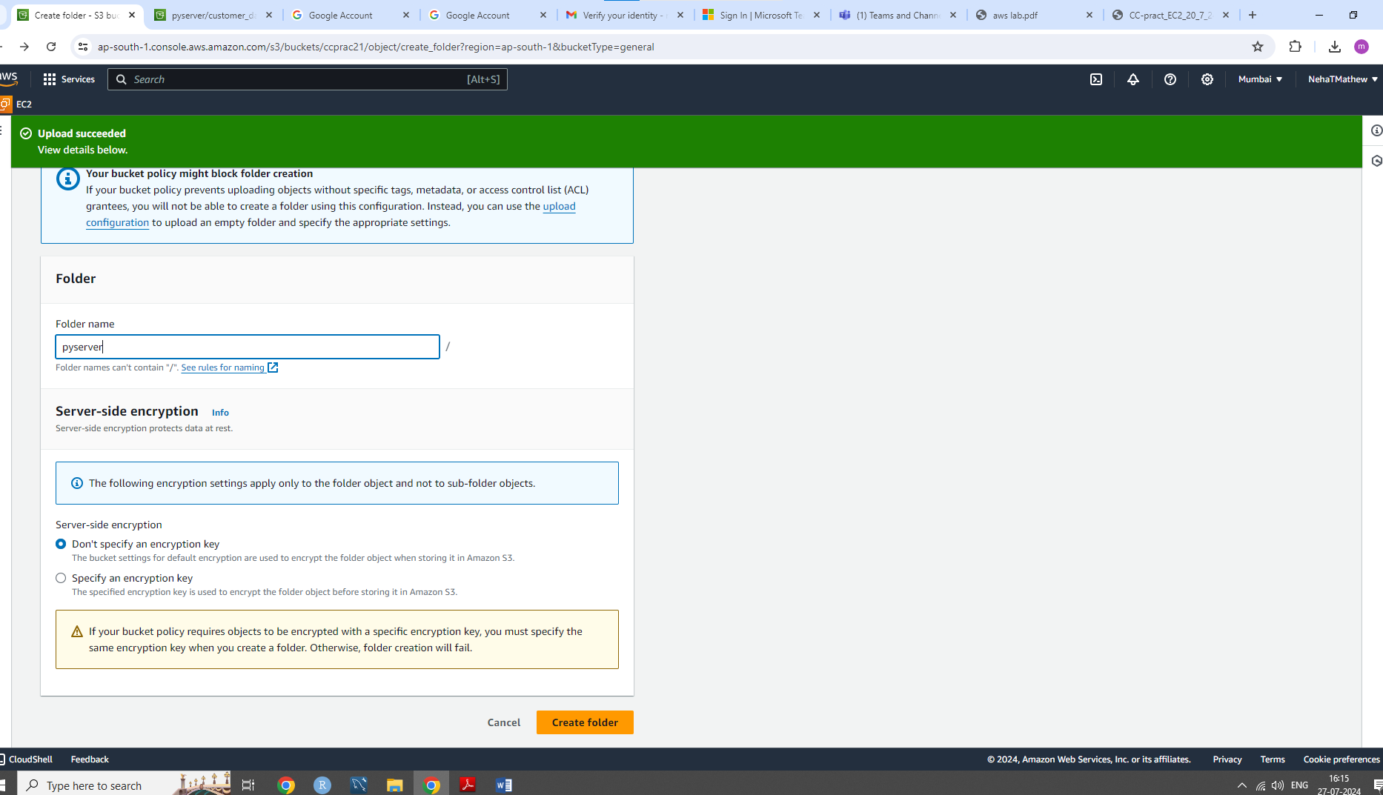

5)After creating a folder “pyserver “ click on the folder and then upload the “page.html “ that was created in the beginning

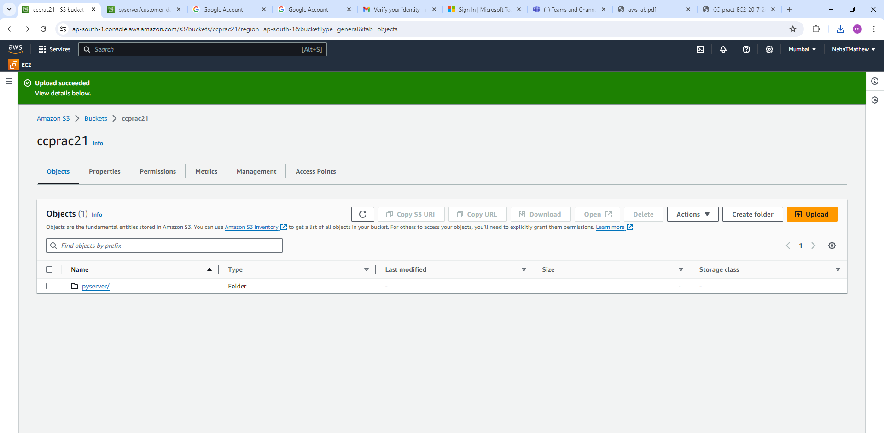

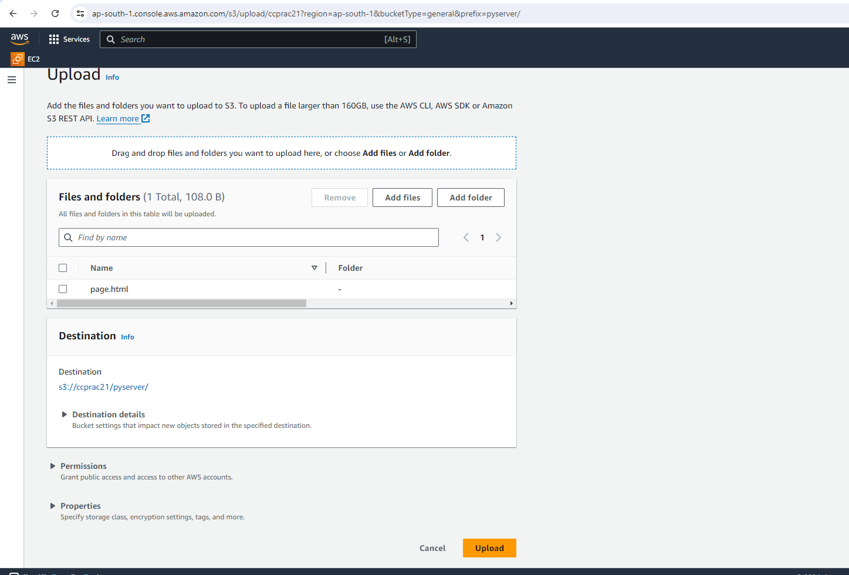

6)Once the upload status is shown as successful, click on the file uploaded and press on the open button

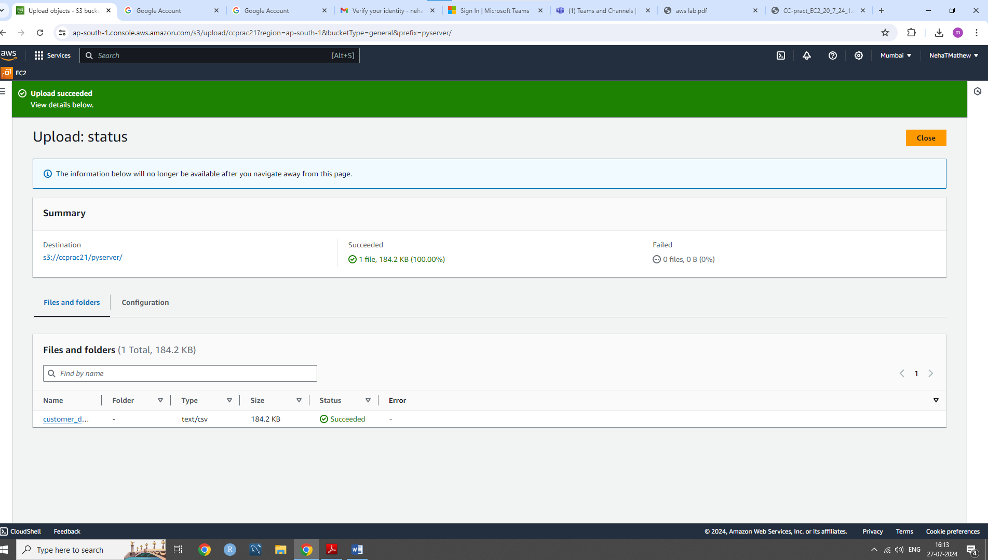

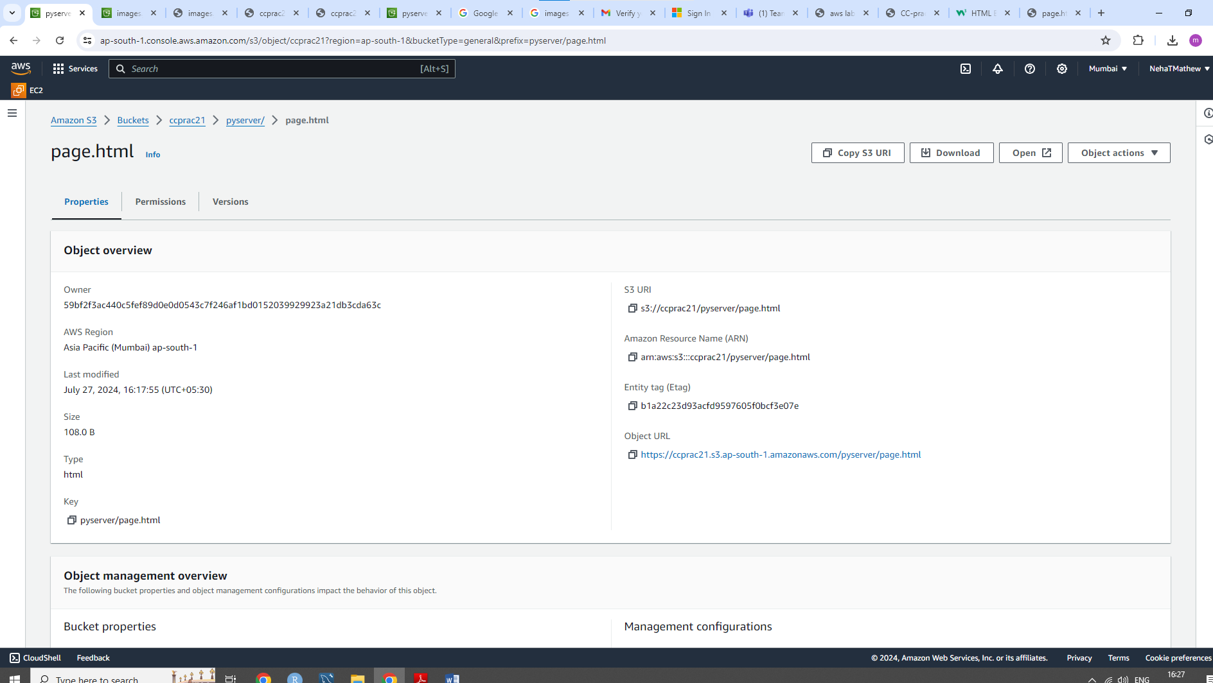

7)Finally we have uploaded a basic html page .

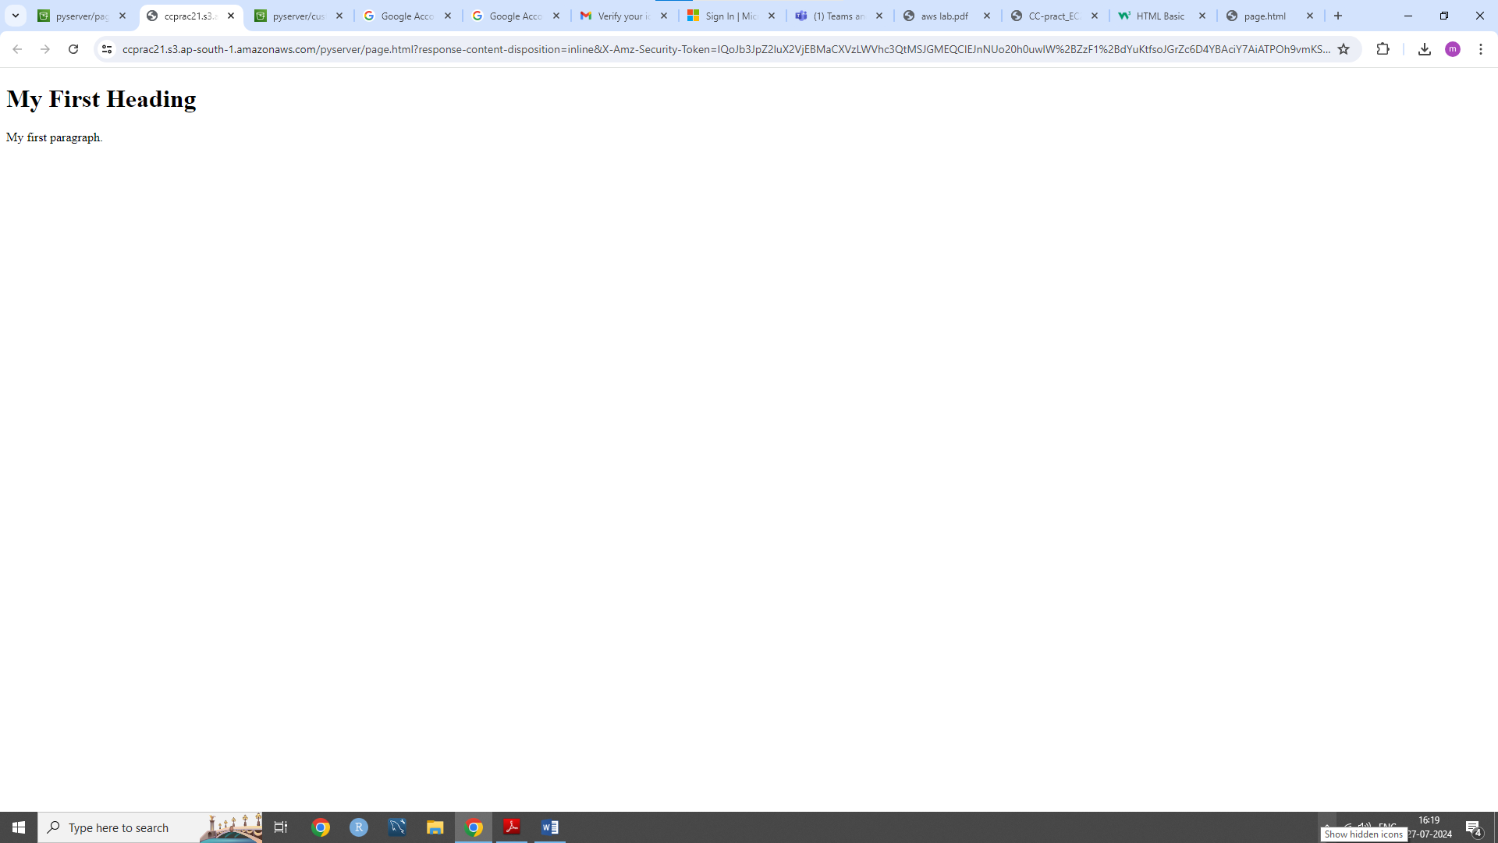

**2) Upload an image:**

1.Download any image from google and save it as .png, .jpg, .tif or any other image format

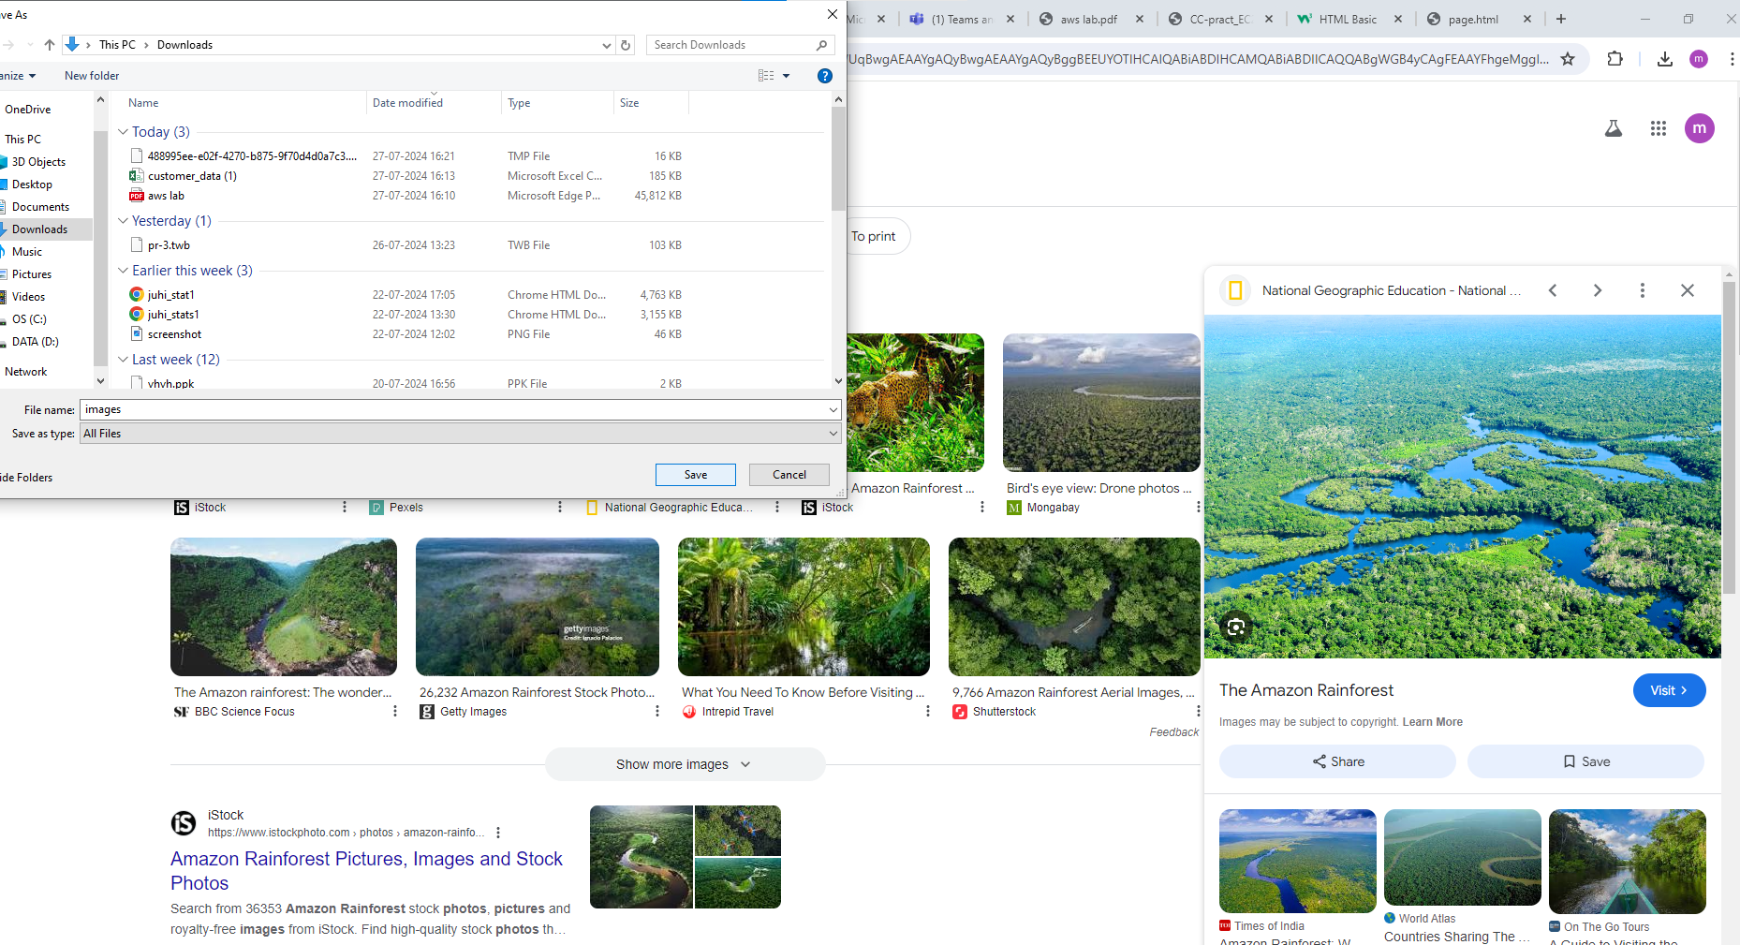

2.Now go to the bucket “ccprac21” that we created and upload the image that we had downloaded earlier

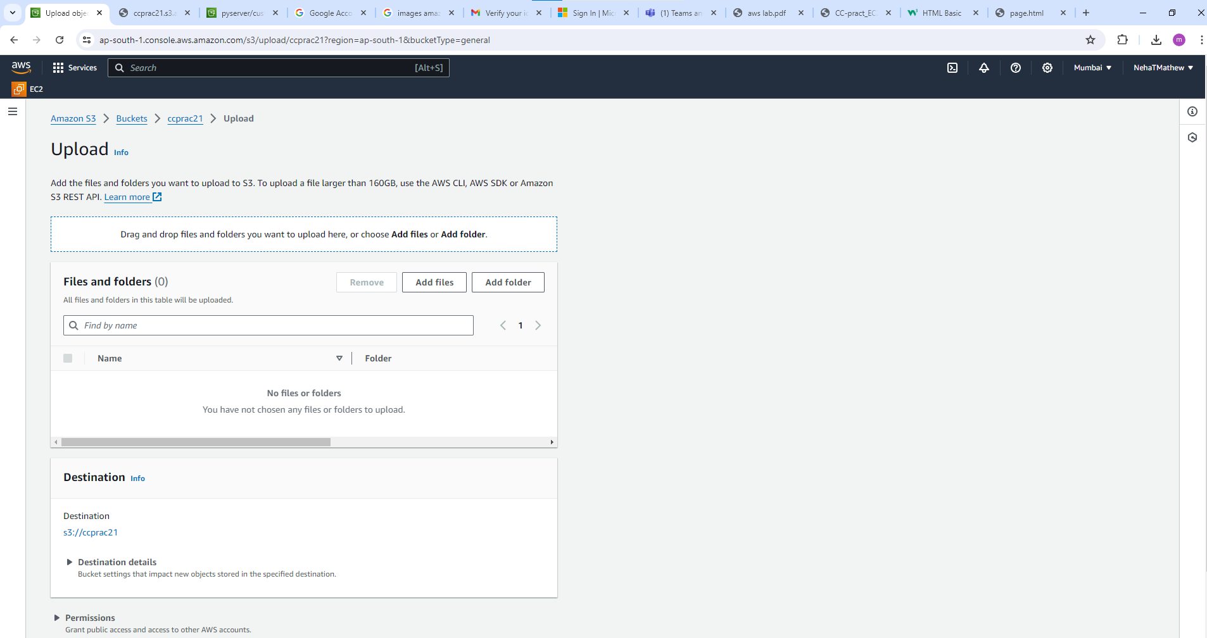

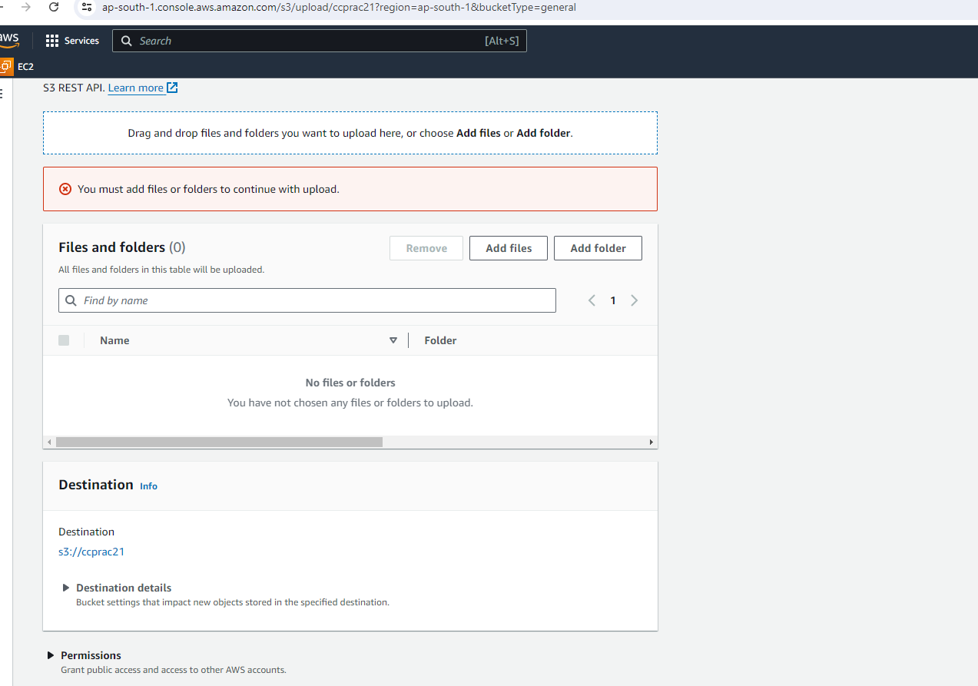

3.Once the upload is successful, click on “open”

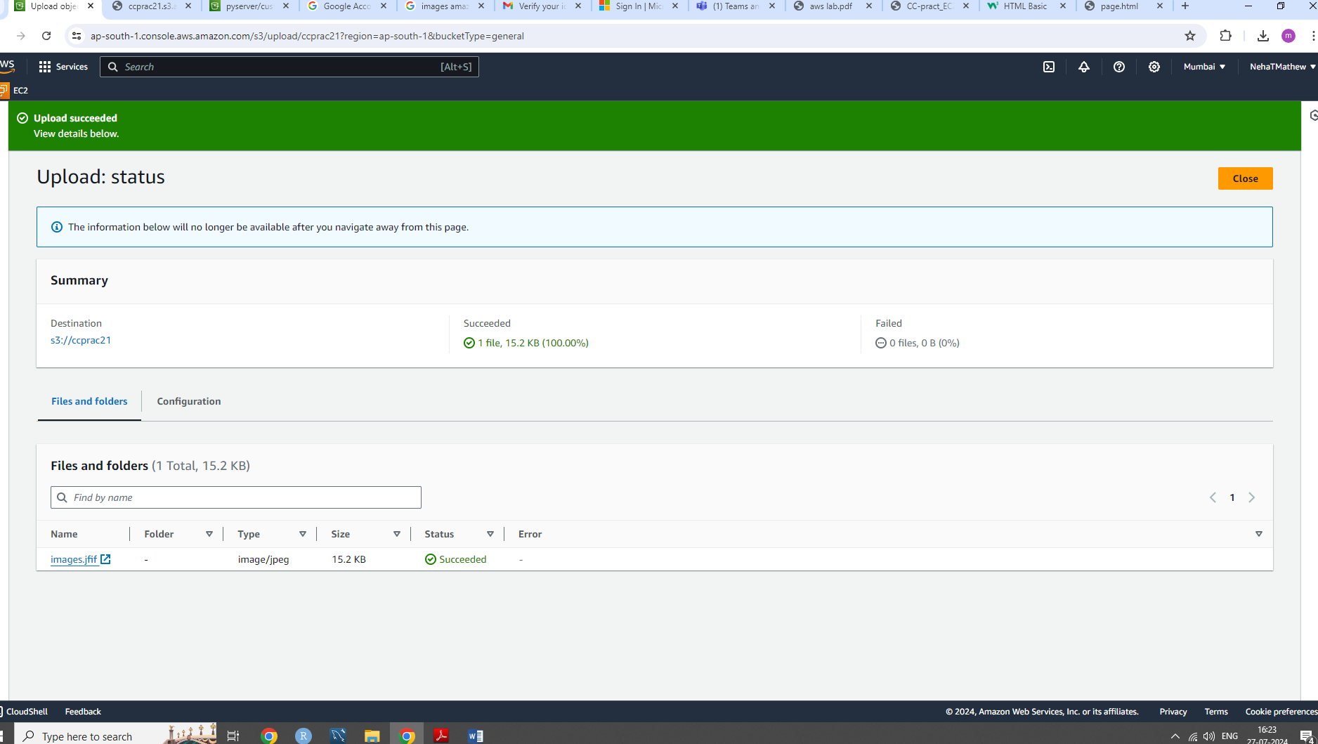

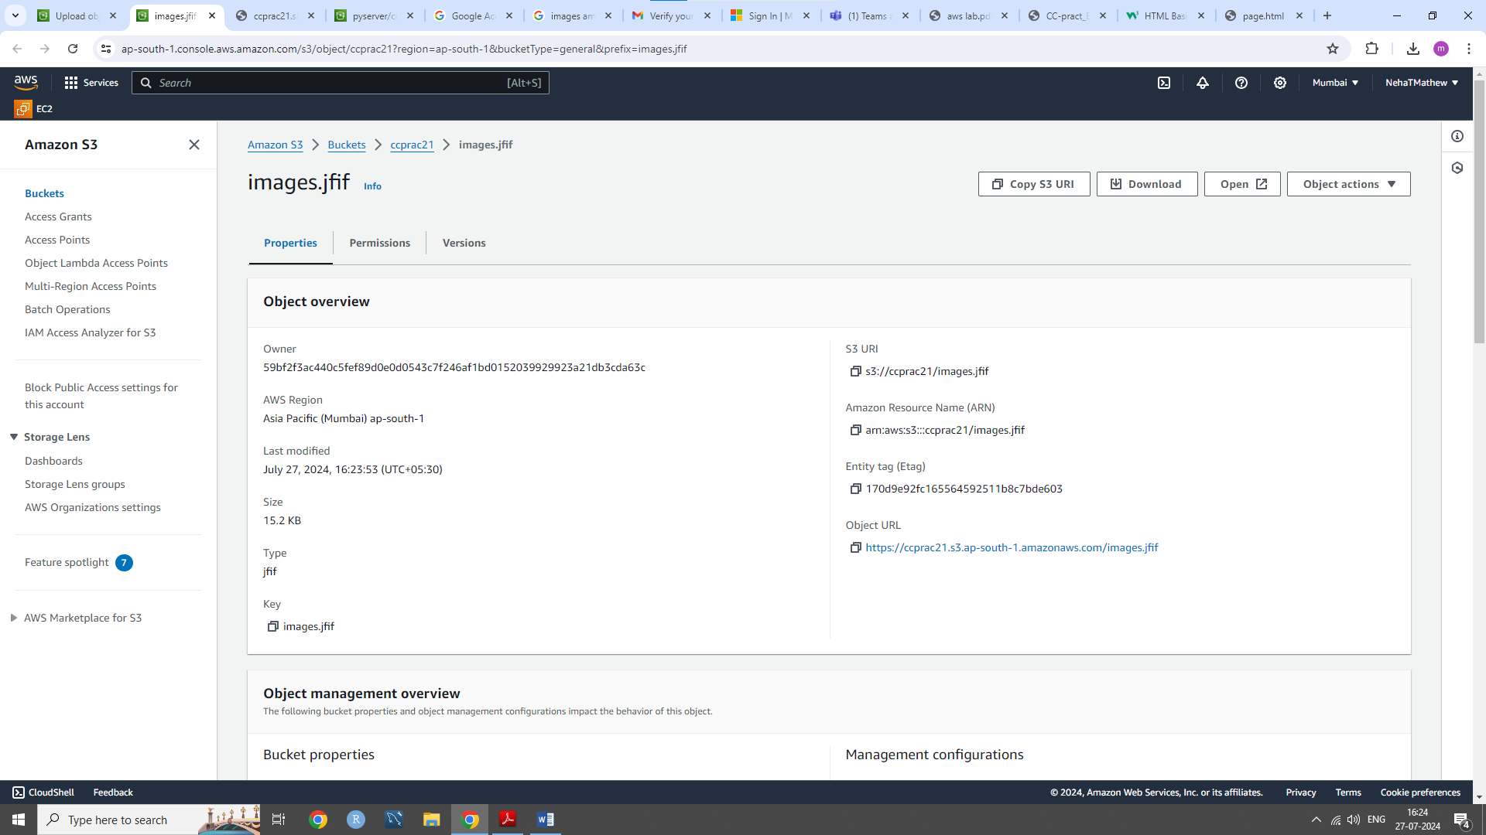

4.And finally the image has been uploaded!

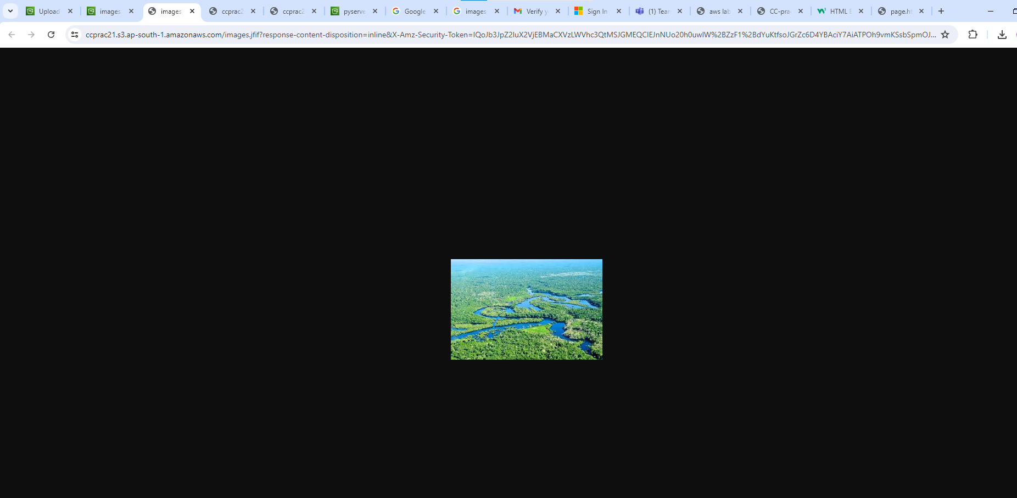

**3)Upload HTML Website:**

1.Write the front-end HTML code for a website and save it as “mywebsite.html” in Notepad.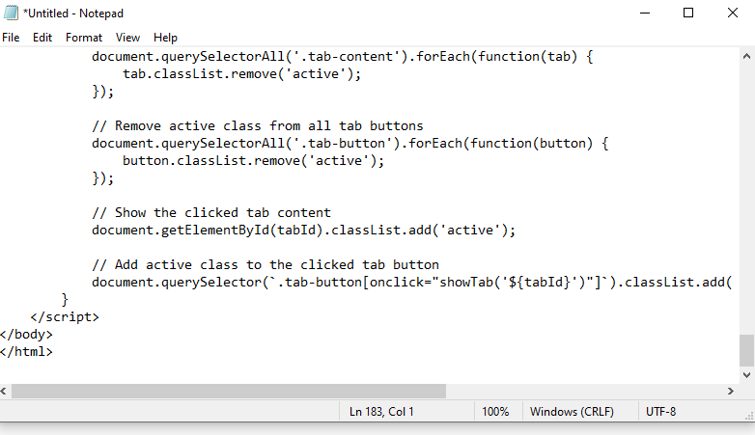

2.Upload the “mywebsite.html” file to the "ccprac21" bucket.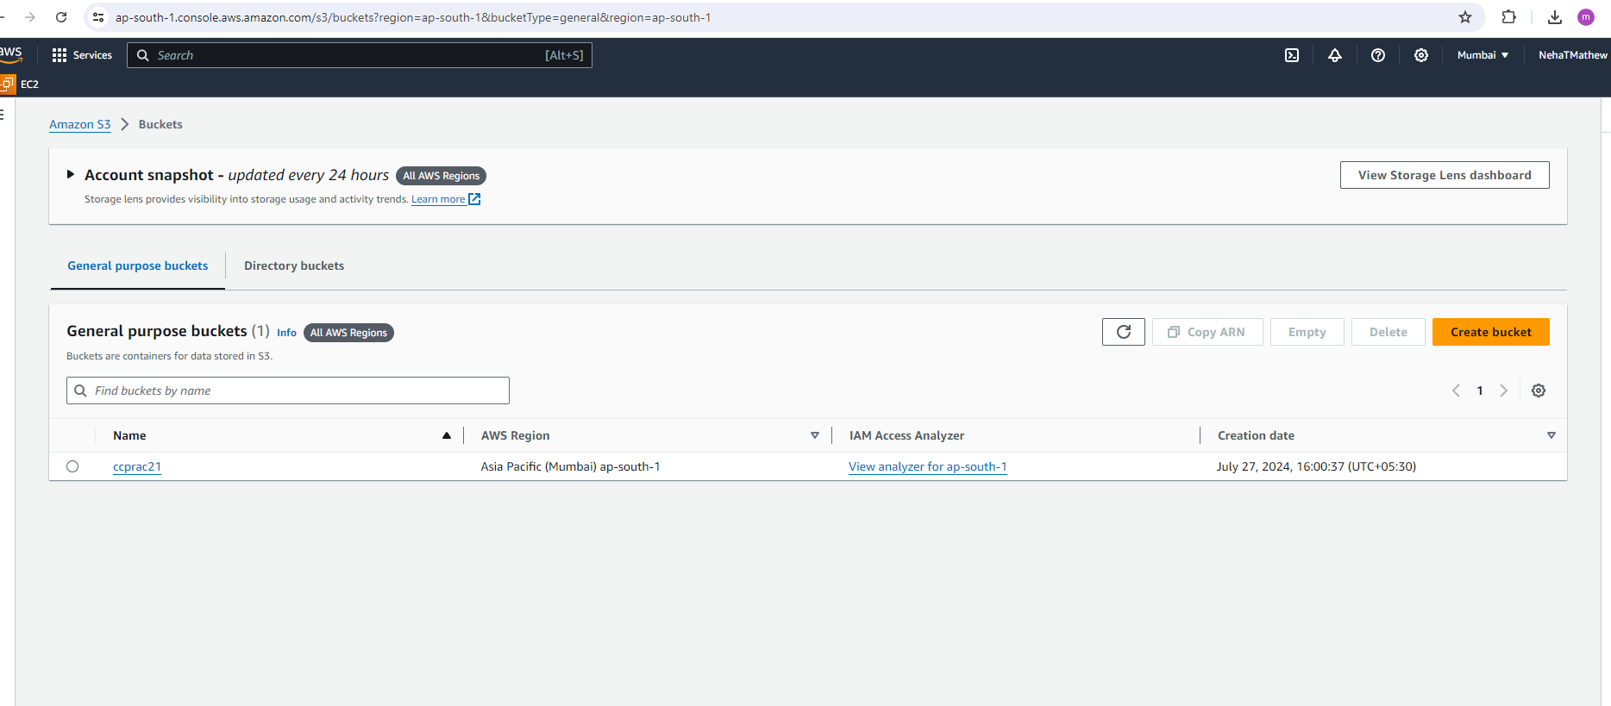

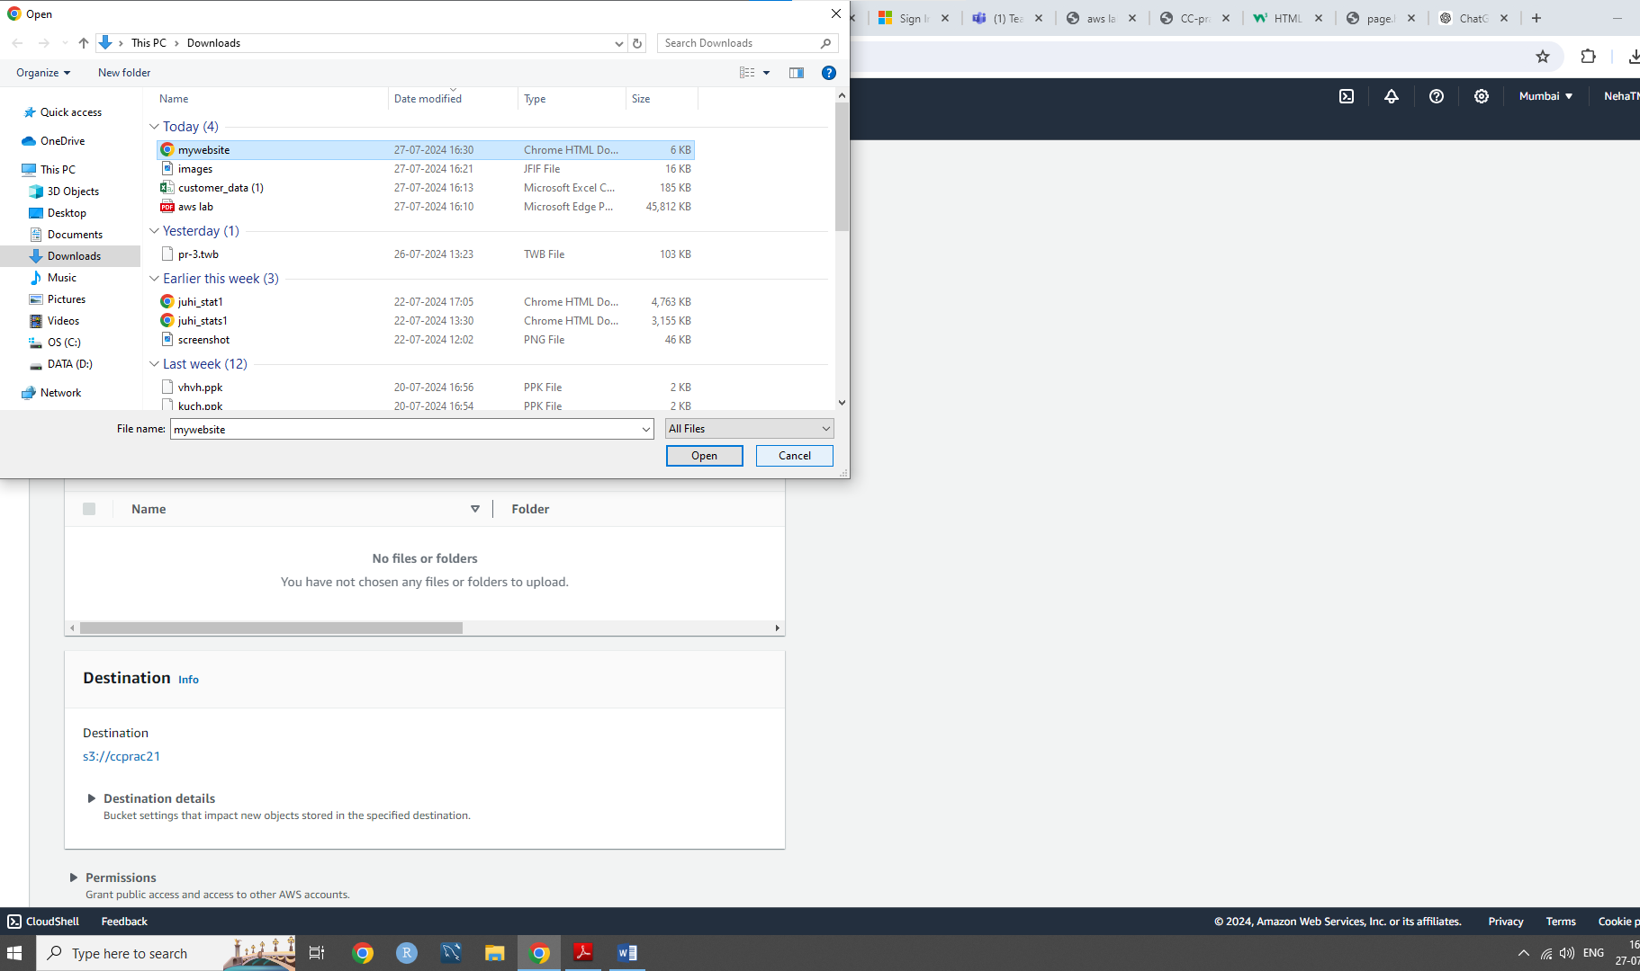

3.After a successful upload, open the file to launch your website.

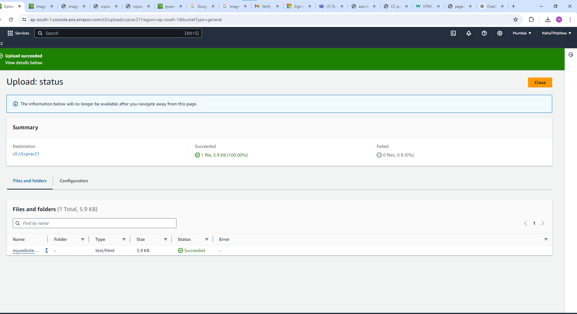

4.The website setup is now complete.

